ARE YOU AT RISK OF TRAFFICKING?
BE ALERT
- Be careful of any tempting offers of employment, study or marriage abroad made by casual acquaintances or friends.
- If you accept a job offer, make sure that there is a legitimate contract or another signed agreement.
- Do not trust announcements offering job, study or marriage abroad. Always verify and check information provided in such announcements. As a rule, offers on quick, easy and high income are fake. You must be prudent and cautious.
- Look out on the Internet to find the address of companies inviting you to work; consult representatives of organizations or the authorities on the whereabouts and reputation of such companies or potential employers.
- Do not accept any suspicious gifts by acquaintances or unknown to you people.
- If the person offering you the opportunity gives only vague information or is asking for secrecy – especially if they are asking you to keep it a secret from your family – be very cautious.
- Do not give your personal documents or mobile phones to anyone apart from the authorities.
- Do not accept to be taken somewhere by people you don’t know well enough, especially without knowing where they are taking you and what for.
- Does the person make you feel uncomfortable? Trust your instincts.

ASK FOR HELP
If anyone threatens you or tries to make an offer that seem suspicious, do not be afraid to call 112 (European Emergency Line) or to contact the organizations below.
 | Rotušės a. 23 Kaunas, LITHUANIA  +370 679 61617​  info@anti-trafficking.lt
 | National Association against Trafficking in Human Beings  24/7: 800 91119 (free calls from Lithuania)  +370 61691119 (from all countries, in En, Lt, Russian)  info@stop-trafficking.lt
 | PO Box 5, EN 00 – 956 Warsaw 10, POLAND  +48 22 628 99 99​  strada@strada.org.pl
 | Lützowstr.102-104, Hof 1, Aufgang A, 10785 Berlin​, GERMANY  +49 30 263 911 76​  info@kok-buero.de
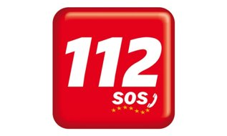 | European Emergency Line – works in any EU country with no need to digit a country code

